In case if we don’t have any API’s to do practise then fake API’s can be downloaded by executing the following command

Note: In order to download the API’s from the below command, we should have node.js installed on our system.

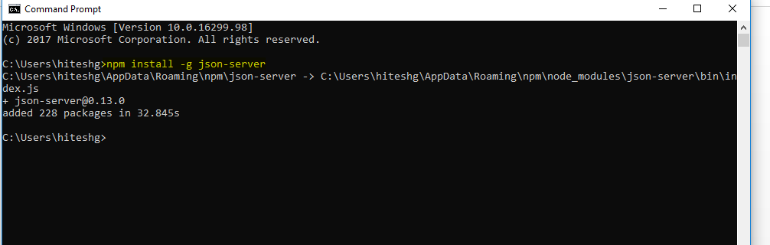

Now, we have our own API server to call it

Once all the packages are installed then issue the following command